Guide to using the Nursing Simulation Scheduling App
The Nursing Simulation Scheduling App allows you to generate optimized weekly lab schedules for Senior, Junior, and Accelerated nursing student groups. All model parameters are configured through the sidebar on the left, while the main interface displays the solver button and the generated schedule.
The sidebar contains multiple parameter sections, so you may need to scroll to view and adjust all settings.
Sidebar: This is where we change the scheduling parameters

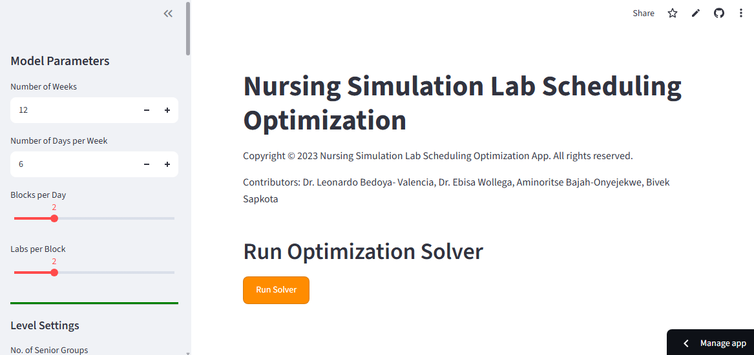
Solver Button: Click to generate the schedule

Model Parameters (Sidebar):
Number of Weeks: This is where we define the total number of weeks in a semester that will be used for scheduling the nursing students to the simulation. The default value is set to 12 weeks
Number of Days per Week: Specifies how many days per week simulation sessions are offered. The scheduling week runs Monday through Saturday. If set to fewer than 6 (e.g., 5), only the first 5 days are used. The default is 6.
Blocks per Day: A block represents a fixed time window (e.g., 4 hours) during which one or more labs can run simultaneously. The default number of blocks per day is set to 2.
Labs per block: Defines how many labs run concurrently within each block. The default is set to 2.
No. of Senior Groups: Total number of Senior student groups requiring simulation sessions. The default is 15
No. of Junior Groups: Total number of Junior student groups. The default is 12
No. of Accelerated groups: Total number of Accelerated student groups.The default is 15
No. of Senior Lab sessions: Total number of simulation sessions each Senior group must attend during the semester. The default is set to 4
No. of Junior Lab Sessions: Total number of simulation sessions each Junior group must attend. The default is set to 4
No. of Accelerated Lab Sessions: Total number of simulation sessions each Accelerated group must attend. The default is set to 7
Block Availability: This section defines which days of the week each student level is allowed to attend lab.
For example:
- Senior students: Monday, Wednesday, Saturday
- Junior students: Tuesday, Wednesday, Thursday, Saturday
- Accelerated students: Tuesday, Thursday, Friday, Saturday
You can adjust these availability rules using checkboxes for each day.
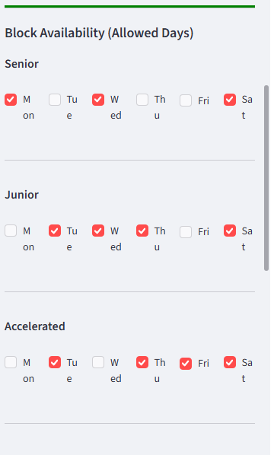

Lab Arrangement: For each day of a week, we can define which lab is available for each block. This needs to be defined for each day of the week. The figure below illustrates the lab defined for Monday in which only the lab2 is available for block 1.
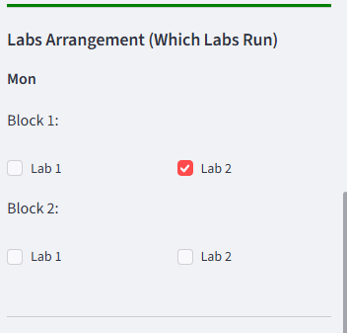

After all the model parameters are set, just click “Run Solver”. This will generate the schedule for each week, the section of which is illustrated below. The generated schedule can be copied and pasted to word document or can be downloaded as text file.
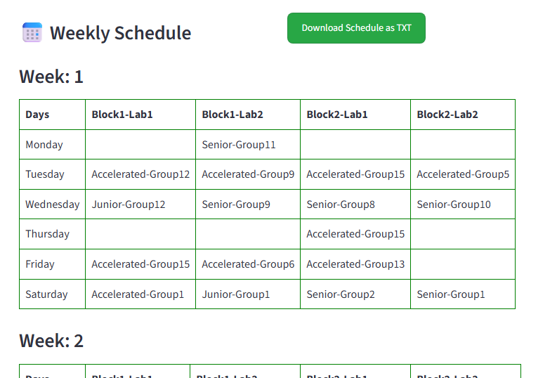

----------------------------------------------------End of Guide--------------------------------------------------------

